**A**

**PROJECT REPORT**

ON

**The Energy Hub**

Submitted in partial fulfillment for the award of

**Post Graduate Diploma in Advance Computing**

**(PG-DAC) from**

**DR. D. Y. PATIL PRATISHTHAN'S**

**INSTITUTE FOR ADVANCED COMPUTING AND**

**SOFTWARE DEVELOPMENT**

**Authorized Training Centre**



**Guided By:**

Mr.Kashinath patil

**Submitted By:**

* Reshma Jagade (210541281069)
* Shruti Jagtap (210541281187)



**CERTIFICATE**

This is to certify that the project report entitled **The Energy Hub** is a bonfire work carried out by **Ms. Shruti Jagtap, Ms. Reshma Jagade** andsubmitted in partial fulfilment ofthe requirement for the C-DAC ACTS, DAC course in

Dr. D. Y. Patil Pratishthan's Institute for Advanced Computing and Software Development in the batch of May 2021.

**Mr.Prashant Karhale**

**Course Coordinator** **External Examiner**

**Acknowledgement**

This project **The Energy Hub** was a great learning experience for us and we are submitting this work to Advanced Computing Training School (CDAC).

We are very glad to mention the name of ***Mr.Kashinath patil***

for their valuable guidance to work on this project. Their guidance and support helped us to overcome various obstacles and intricacies during the course of project work.

#### We are highly grateful to *Mr. Mr. KKP (TPO (IACSD, Training Centre), C-DAC,* for his guidance and support whenever necessary while doing this coursePost Graduate Diploma in *Advanced Computing (PG-DAC)* through C-DAC ACTS, Pune.

#### Our most heart full thanks goes to *Mr.* *Wg Cdr PVC Patil (Retd)*

(Director ,IACSD)who gave all the required support and kind coordination to provide all the necessities to complete the project and throughout the course up to the last day here in C-DAC ACTS, Pune.

**Abstract**

In this modern world, computer becomes more and more popular and important to our society. We can use computer everywhere and they are very useful and helpful to our daily life. Like computers online websites has a crucial role in the daily life. Now we have the facility to know about anything in the world through the various sites in a single click. So here we aimed to develop a site based on Gymnasium for keeping records of people comes in the gym.

This project is designed to facilitate a gymming and fitness center to automate its operations of keeping records and store them in form of a large and user friendly database further facilitating easy access to the personnel.

**Index**

|  |  |  |
| --- | --- | --- |
| **Sr. No.** | **Title** | **Page No.** |
| **1** | Introduction | 1 |
| **2** | Problem Definition & Scope | 2 |
| **2.1** | Problem Definition | 2 |
| **2.2** | Goals & Objectives | 2 |
| **2.3** | Major Constraints& Outcomes | 3 |
| **3** | Software Requirement Specification | 4 |
| **3.1** | Purposed System | 4 |
| **3.2** | Scope | 4 |
| **4** | System Modules | 5 |
| **5** | Performance-Requirements | 6 |
| **5.1** | H/W Requirements & S/W Requirements | 6 |
| **6.1** | DFD | 7 |
| **6.2** | Sequence diagram | 8 |
| **6.3** | Deployment diagram | 12 |
| **6.4** | Use case diagram | 13 |
| **6.5** | Entity Relationship Diagram | 15 |
| **7** | Test Cases | 16 |
| **8** | Screenshots | 20 |
| **9** | References | 25 |

**Chapter 1**

**Introduction**

**1.** **The Energy Hub**

Gym Management System is an easy way to use gym and health fitness membership system. It can helps to keep records of members and their memberships, and give permit communication between members. Gym Master is also feature-packed, helping members in the management and growth of health club.

The Energy Hub project is to handle the data of the gym. It is a interface developed using java. This proposed system provides automation in gym records including gym memberships, packages, batches, trainers associated with gym and allows easy communication between them.

**Chapter 2**

**Problem Definition and Scope**

**2.1Problem Definition**

* Existing system was manual.
* Time consuming as data entry which include calculations took lot of time.

**2.2 Goals and Objectives**

**2.2.1 Goals:**

The **goal**  of the “**Gym Management System**” is to provide a **system** which handles the information of the people coming into the **gym** and maintaining their health care.

**2.2.2Objectives:**

This project shall enable the user to add members to a gym. It is a very simple interface developed using java. The user of the system shall be able to add a new gym member. The tool shall add all the necessary details like name, contact details into the system. The system shall also monitor the timings for the member. It shall allow the user to make fee payments. This tool shall hold all the details of gym members.

**2.3 Major Constraints**

Constraints that will affect the application's outcome are listed below:

**2.3.1 Connectivity required:**

Continuous internet connection .

**2.3.2 Manual functionality:**

The user have to click on fare which will be redirect to the specific Gym portal.

**2.4 Outcomes**

**2.4.1 Time efficient:**

To take admission from an offline, you’ll be required to personally visit the Gym training center .When you’ll search gym on web you will get multiple gym names with different facilities . Our portal makes your job easy we provide all information of best Gym and its features and we also provide online registration facility **.**

* + 1. **Availability:**

Because the data is stored on cloud all the information is easily available**24x7** to the end user.

* + 1. **Highly convenient :**

It allows end user to literally take membership From The Energy Hub gym .No matter if you are at home, office or traveling, you can take membership of gym and you will able to maintain your healthcare.

The online gym management system is user-friendly application. This automated system makes all functionality easier for both owners and customers. It is very simple in design and to implement. The system requirements are very low. System resources and the system will work in almost all configurations.

.

**Chapter 3**

**3.1 Proposed System:**

The proposed system **The Energy Hub** , web application was developed for everyone who is interested in gym for their health care . The application, which provide different type of packages and its price depending upon the user’s preference it will get the appropriate package. It is an open source application, it was developed to run on any browser which is running on any operating system.

**3.2 Scope:**

This project is helpful in the Automation of gym record including gym batches, packages, membership and gym Management System

**Chapter 4**

**System Modules:**

4.1 Main Energy Hub Portal:

We developed the Gym portal for end to aware about their health care. Here it get information about gym ,our team, contact etc.

4.2 Member Portal:

We developed the Gym portal for end user for taking membership of The Energy Hub gym. Here it takes the services from different branches,packages of gym and show information of gym for end user.

4.3Admin portal:

In this module we developed the gym admin portal. In which admin can control mean admin can edit add ,delete ,update and view the information of member, trainer, batches and packages.

4.4 Trainer Portal:

In this module the trainer will add all the credential for login and after login it will show all information about trainer itself and their batches.

**Chapter 5**

**Performance-Requirements:**

**5.1 Hardware Requirements:**

The minimum hardware requirements of Gym application are a 500 Megahertz CPU and 128 Megabytes of RAM.

**5.2 Software Requirements:**

* Eclipse IDE
* Tomcat server
* MySQL database
* Any Web browser

**Chapter 6**

**Diagrams:**

**6.1 DFD Diagrams:**

DFD-Level 0:

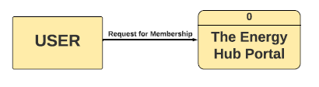

DFD-Level 1:

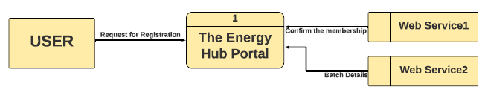

DFD-Level 2:

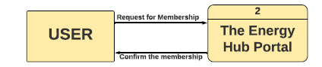

Sequence Diagrams:

1.Admin sequence:

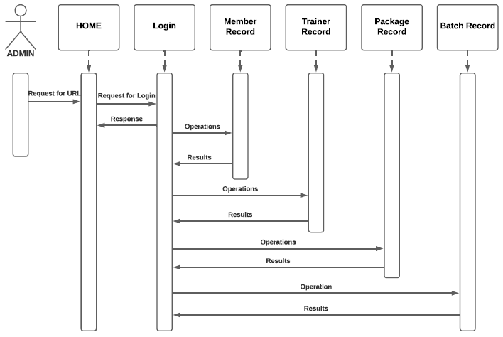

2.Trainer sequence:

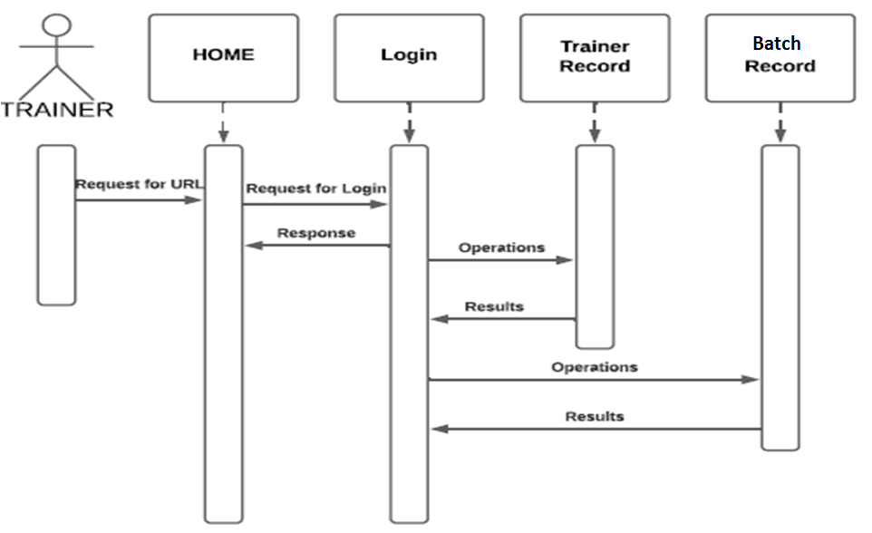

3.Member sequence:

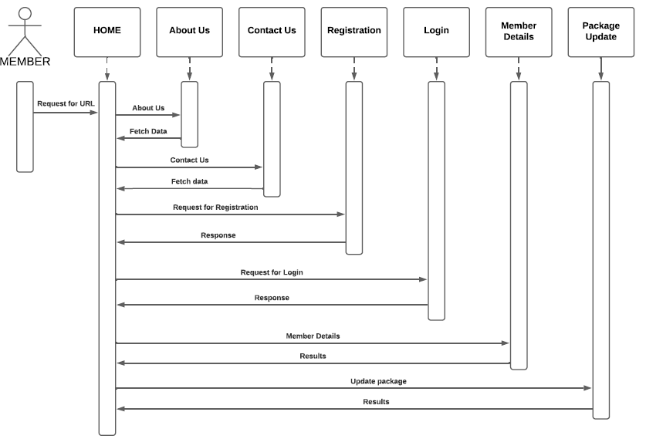

**6.3 Deployment Diagram**:

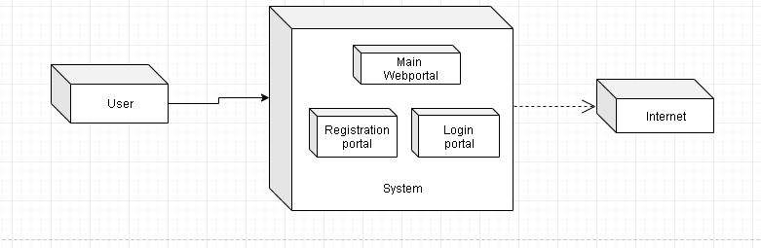

**6.4 Use Case Diagram**:

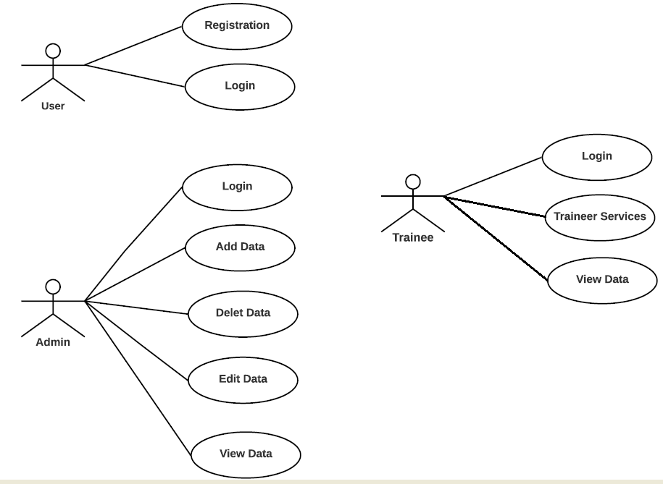

6.5 Entity Relationship Diagram:

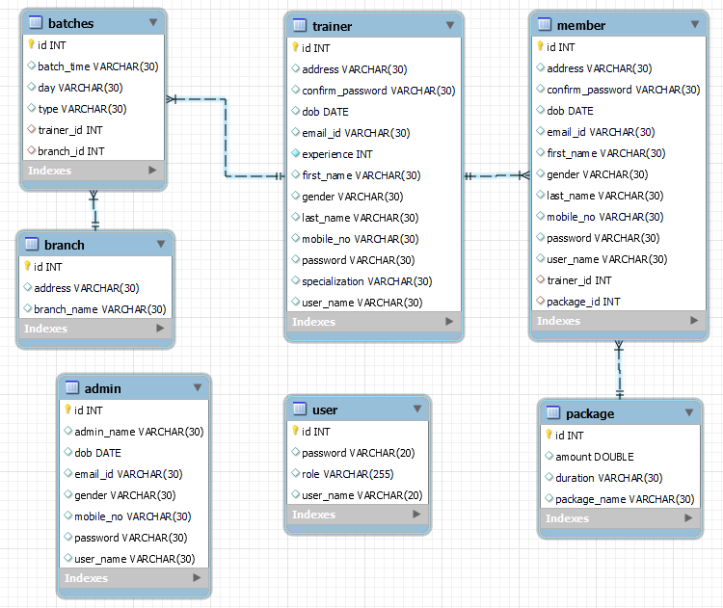

**Chapter 7**

**Test Case:**

|  |  |  |  |
| --- | --- | --- | --- |
| **Project Name:** | The Energy Hub | **Test Designed by:** | Shruti Jagtap,  Reshma Jagade |
| **Test Designed date:** | 19/09/2021 | **Test Execution date:** | 25/09/2021 |

|  |  |
| --- | --- |
| **Precondition** | Home Page URL ,Redirection From Home Page |
| **Dependencies:** | Internetconnection ,web browser |

|  |  |  |  |  |  |  |
| --- | --- | --- | --- | --- | --- | --- |
| **Test Case ID** | **Test Title** | **Test Steps** | **Test Data** | **Expected Result** | **Actual**  **Result** | **Status** |
| TC1 | Check Home Page  URL | 1. Go to Browser |  | User Should Get Home Page | As Expected | Pass |
|  |  | 2. Enter Home Page  URL |  |  |  |  |
|  |  |  |  |  |  |  |
| TC2 | Check Home Page  UI | 1. Go to Browser |  | User Should get Gym portal  On which registration ,login, other information of gym ,team members link. | As Expected | Pass |
|  |  | 2. Enter Home Page  URL |  |  |  |  |
|  |  | 3. Click Enter |  |  |  |  |
|  |  |  |  |  |  |  |
| TC3 | Check registration form field | 1.Enter user details as per validations |  | User Should redirect to login page | As Expected | Pass |
|  |  |  |  |  |  |  |
| TC4 | Member Login | 1.Enter user Name  2. Enter User password | Username-rama  Password-111 | User Should get Update packages and see details | As Expected | Pass |
|  |  |  |  |  |  |  |
| TC5 | Admin Login | 1.Enter Name  2. Enter password | Admin name-reshma  Password-123 | Admin should get control over member data ,trainer data,package data and batches data | As Expected | Pass |
| TC6 | Trainer Login | 1.Enter Name  2. Enter password | Username-sam  Password-111 | Trainer should get batch details and trainer details. | As Expected | Pass |
|  |  |  |  |  |  |  |
| TC7 | Check Functionality  About us button | Click on about us |  | User Should able to see information about gym | As Expected | Pass |
|  |  |  |  |  |  |  |
| TC8 | Check Functionality  Our team button | Click on our team  Button |  | User Should able to see information about team . | As Expected | Pass |
|  |  |  |  |  |  |  |
| TC9 | Check Functionality  Contact us | Click on contact us button |  | User Should able to see information related contact of gym. | As Expected | Pass |
|  |  |  |  |  |  |  |
| TC10 | Check Functionality  Program button | Click on Program button |  | User Should able to see which programs gym provides to user. | As Expected | Pass |
|  |  |  |  |  |  |  |
| TC11 | Member Login | 1.Enter invalid user Name  2. Enter User password | Username-xyz  Password-1212 | User Should redirect on login page | As Expected | Pass |
|  |  |  |  |  |  |  |
| TC12 | Member Login | 1.Enter valid user Name  2. Enter invalid password | Username-shubham  Password-111 | User Should redirect on login page | As Expected | Pass |
|  |  |  |  |  |  |  |
| TC13 | Member Login | 1.Enter invalid user Name  2. Enter invalid password | Username-xyz  Password-1212 | User Should redirect on login page | As Expected | Pass |
|  |  |  |  |  |  |  |
| TC14 | Admin Login | 1.Enter invalid Name  2. Enter validpassword | Username-xyz  Password-1212 | User Should redirect on login page | As Expected | Pass |
|  |  |  |  |  |  |  |
| TC15 | Admin Login | 1.Enter valid Name  2. Enter invalid password | Username-reshma  Password-123 | User Should redirect on login page | As Expected | Pass |
|  |  |  |  |  |  |  |
| TC16 | Trainer Login | 1.Enter invalid trainer Name  2. Enter invalid password | Username-xyz1  Password-1213 | User Should redirect on login page | As Expected | Pass |
|  |  |  |  |  |  |  |
| TC17 | Trainer Login | 1.Enter valid trainer Name  2. Enter invalid password | Username-alice  Password-111 | User Should redirect on login page | As Expected | Pass |
|  |  |  |  |  |  |  |
| TC18 | Trainer Login | 1.Enter invalid Name  2. Enter invalid password |  | User Should redirect on login page | As Expected | Pass |
|  |  |  |  |  |  |  |
| TC19 | Logout button functionality | Click on logout button |  | User Should redirect on login page | As Expected | Pass |

**Screenshots:**

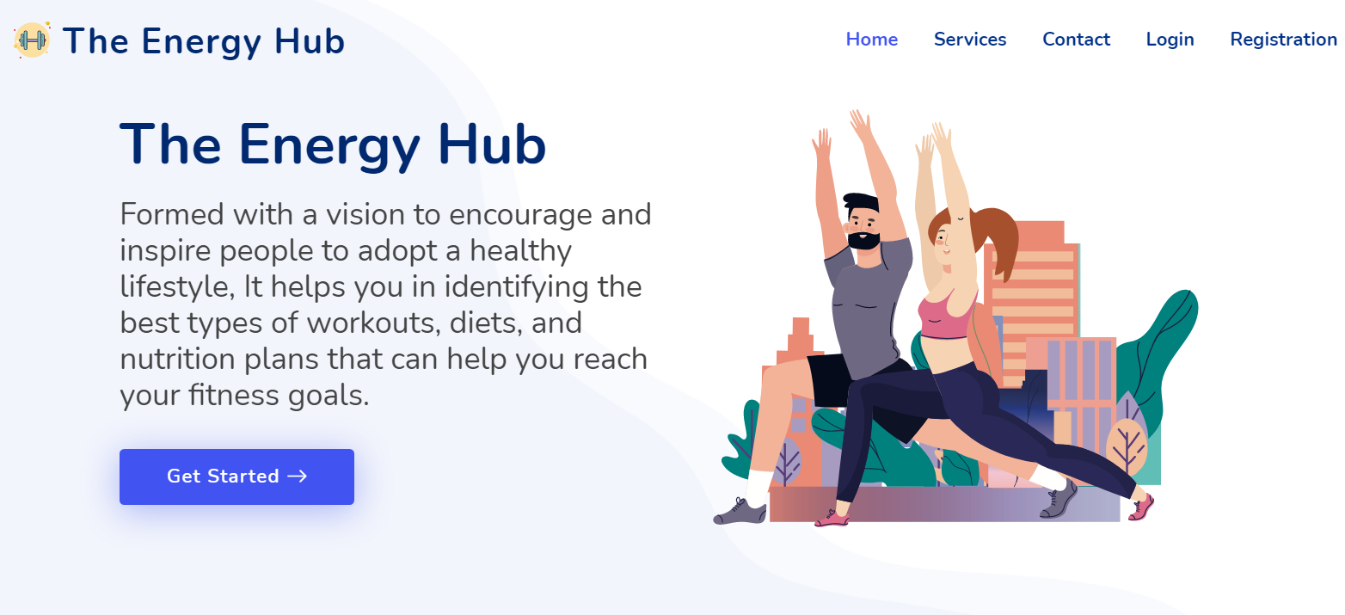

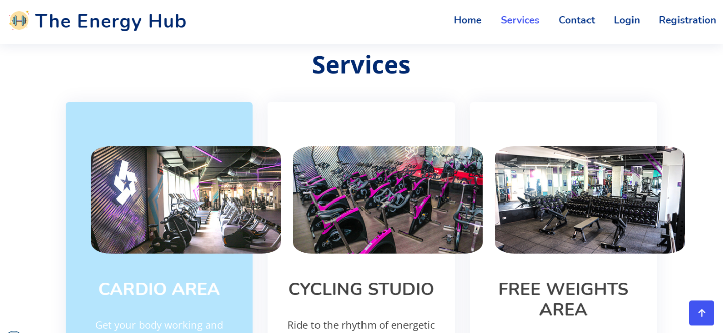

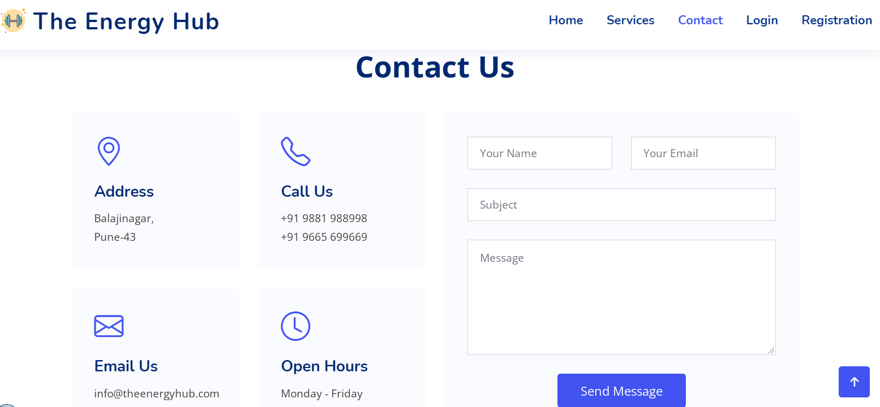

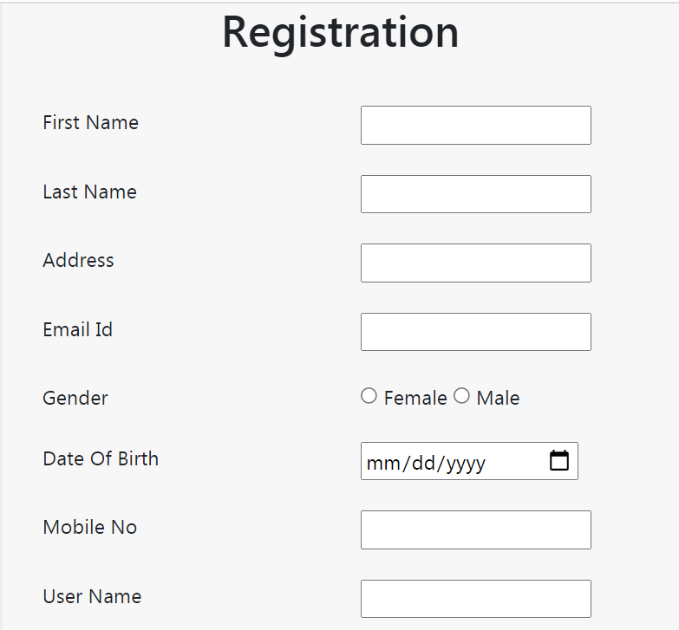

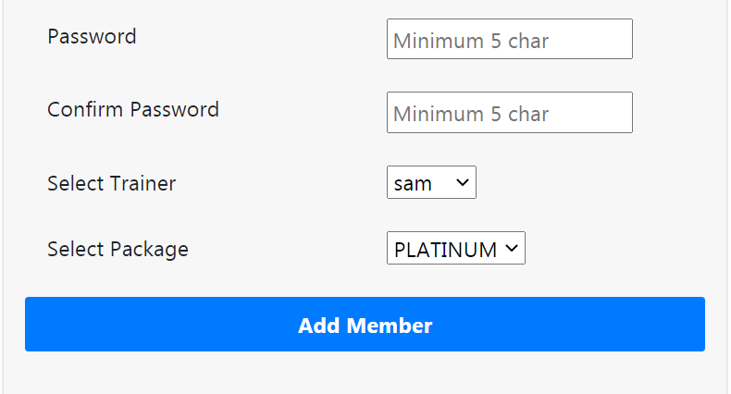

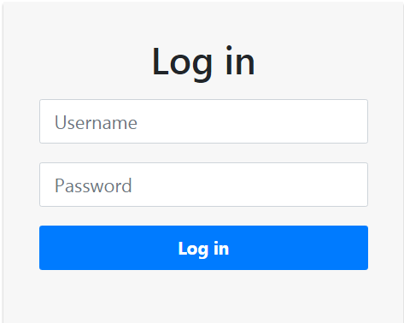

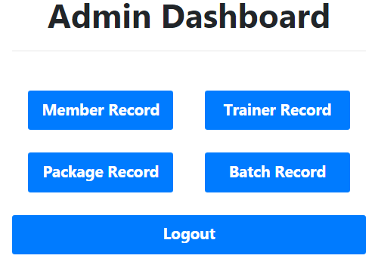

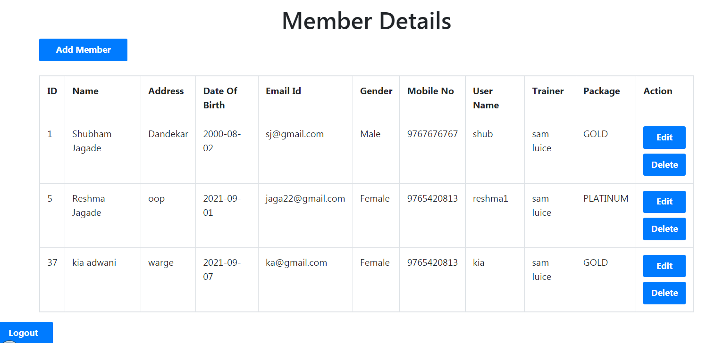

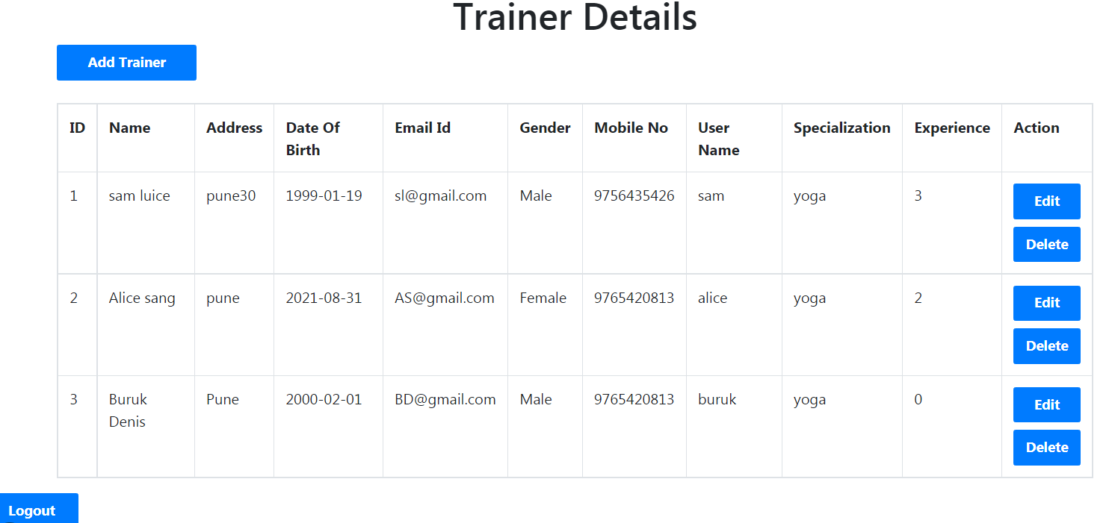

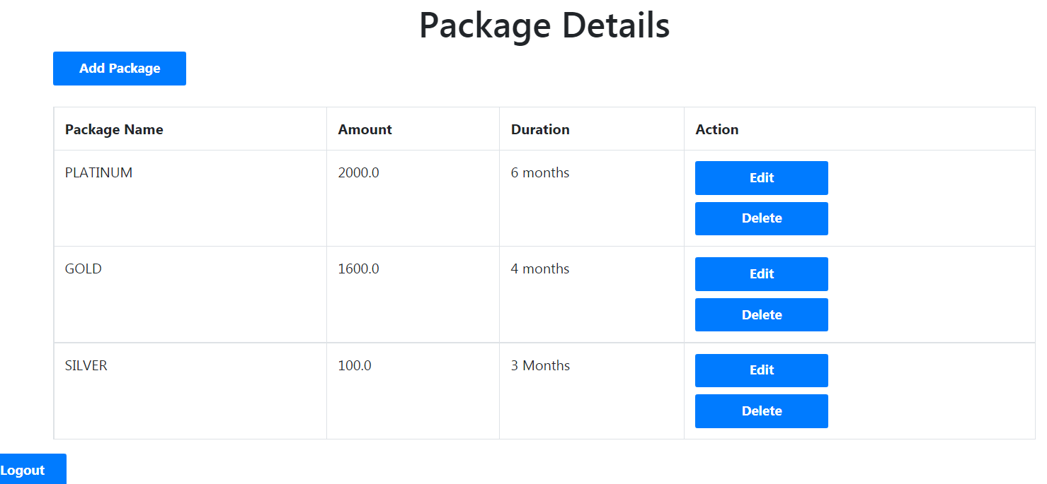

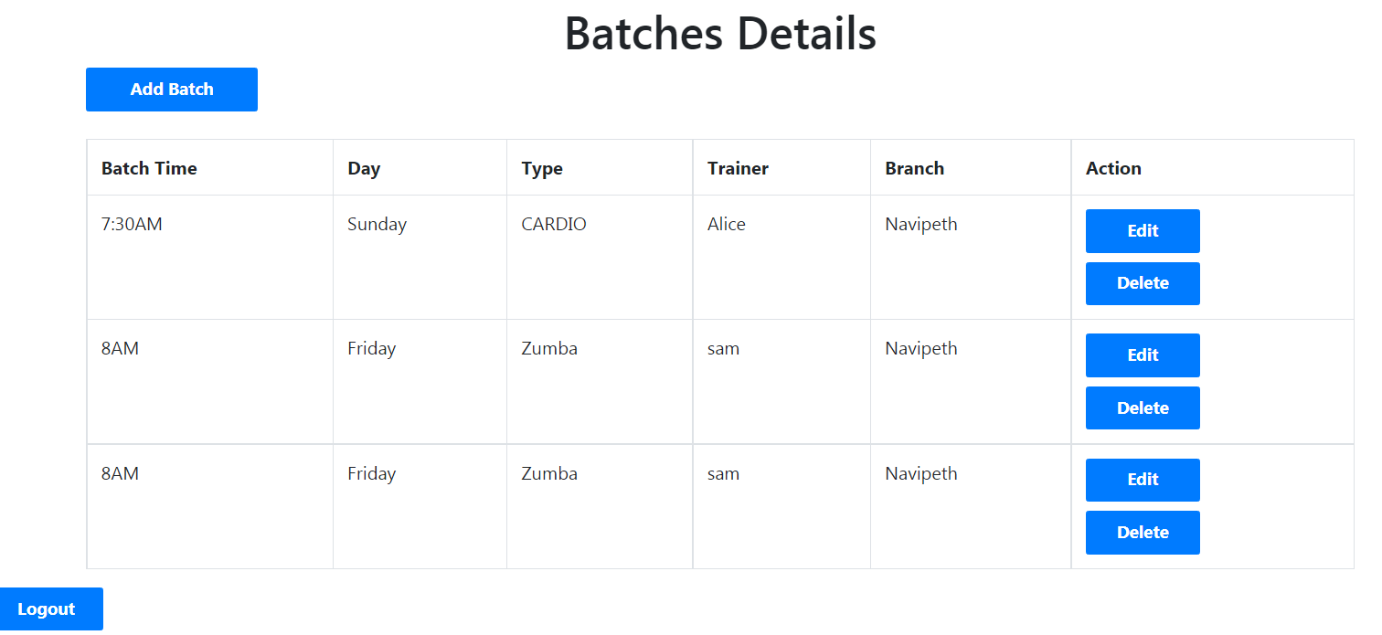

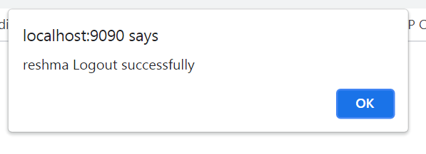

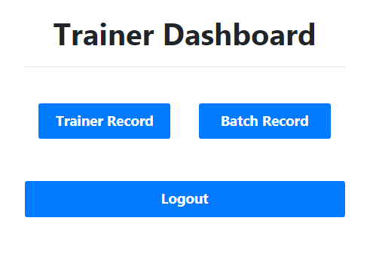

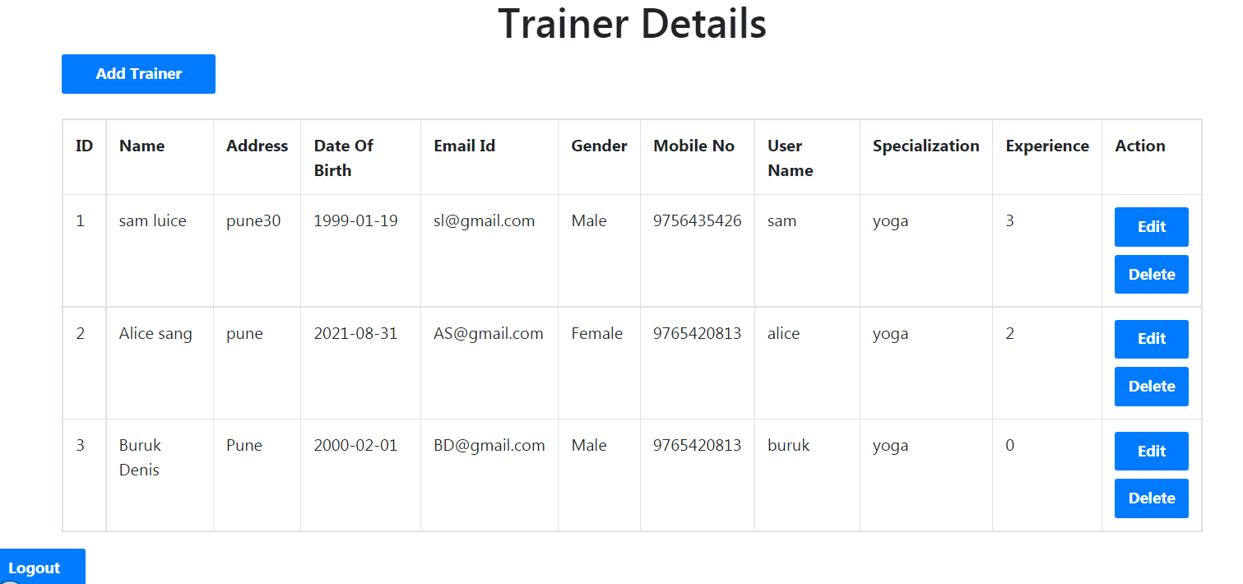

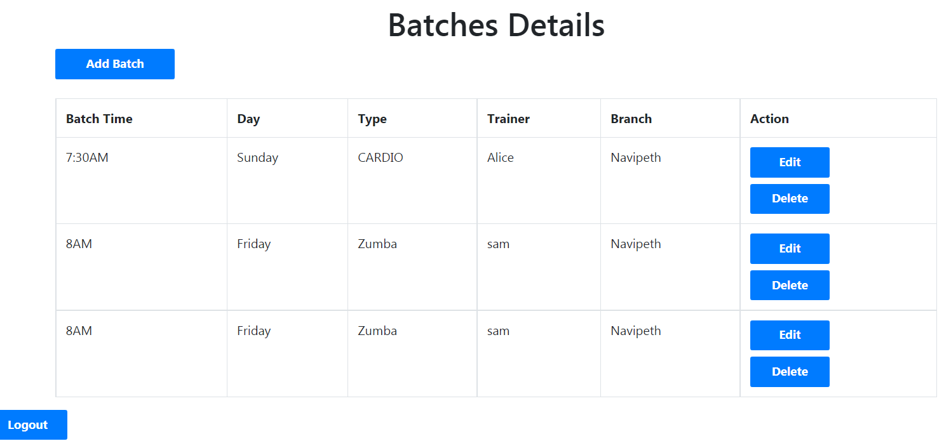

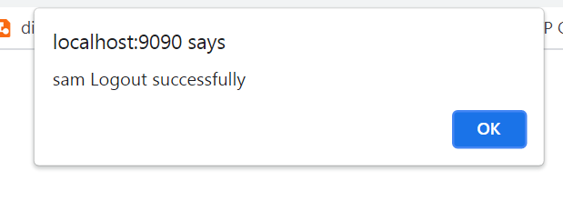

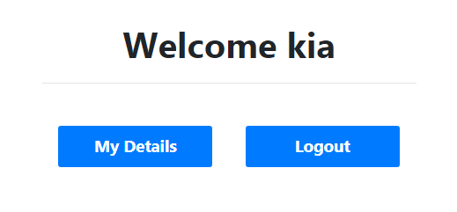

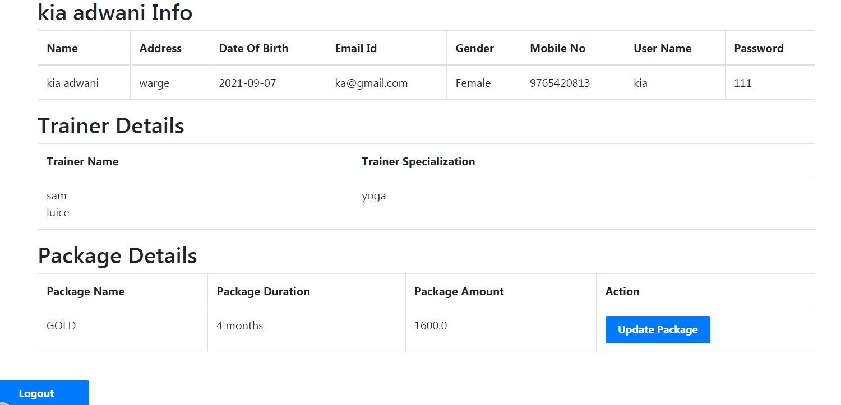

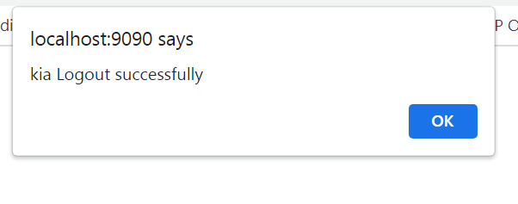

**10 .References**

* Fitness Gym
* www.wikipedia.com
* www.tutorialspoint.com
* https://www.apachefriends.org/download.html
* https://jquery.com
* <https://howtodoinjava.com/hibernate/hibernate-one-to-many-mapping-using-annotations/>
* <https://www.journaldev.com/3524/spring-hibernate-integration-example-tutorial>